Ideation phase

Brainstorm & Idea Prioritization Template

|  |  |
| --- | --- |
| **Project Name** | Iot Based Safety Gadget For Child Monitoring  And Notification |
| **Maximum Marks** | 4 Marks |

**TEAM LEAD: S. THARANI**

**TEAM MEMBER 1: V. RIPPONIKA**

**TEAM MEMBER 2: S. SHARMI**

**TEAM MEMBER 3: S. SHIVANI**

Brainstorm & Idea Prioritization Template:

Step – 1: Team Gathering, Collaboration and Select the problem statement

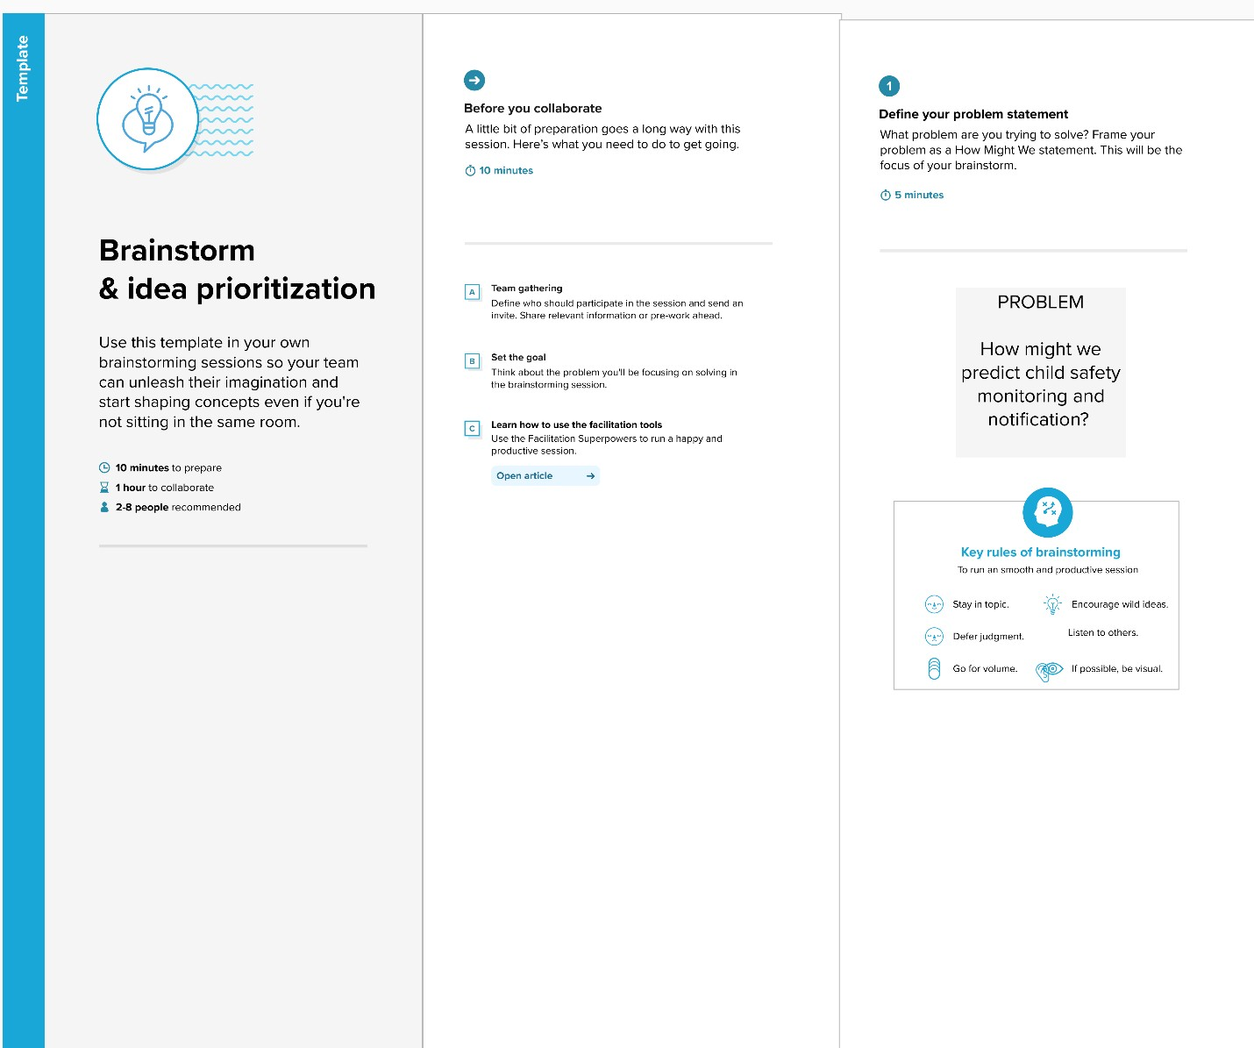

Step – 2: Brainstorm , Idea Listening and Grouping

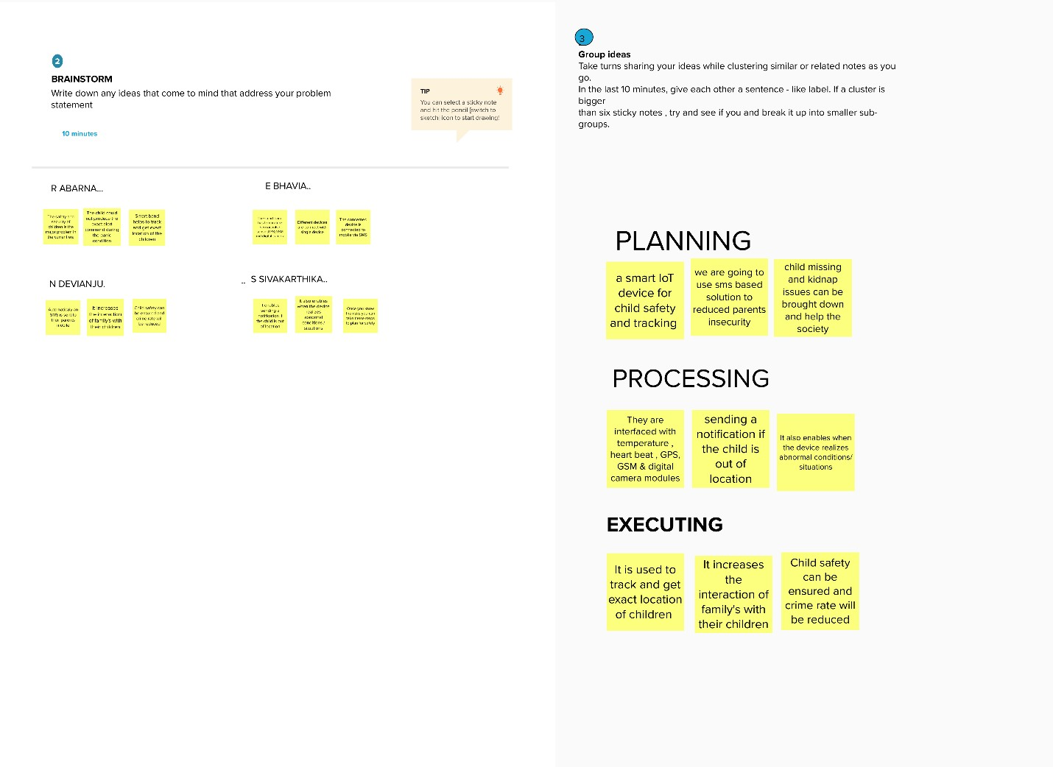

Step – 3: Idea Prioritization

